There are Role Play Games where players only kill monsters and collect weapons, money and experience points.
And there are RPGs filled with flowery clearings, dancing elves and evergreen forests, where players can even bake their own bread.
And then there's:
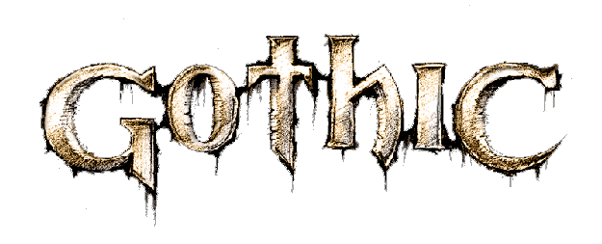

The 3D Action RPG

The Forces of Fate

Condemned and banished into a strange world, the road ahead is yours to choose. Pick one of eight guilds in three different camps, make friends and enemies, learn to fight with a double-bladed axe or choose the fine art of magic and sorcery instead. Learn to move about without making a sound or practise hitting the bulls-eye from 100 feet. Whichever path you choose, your abilities shall determine what adventures you encounter and what challenges you must face up to. Last but not least, your behaviour will decide whether that path will be a long one - or whether you shall end your days being devoured by meat-bugs ...
"Well, no-one said it would be easy." Alex Brüggemann, demon conjurer
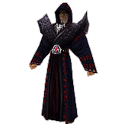

You see what you get

No endless tables and charts, no need to calculate talents and abilities: no numerical chaos.
Whatever your character learns will be visibly represented. You'll see what we mean once you've had your first heavy training ... moves that look more fascinating will be more powerful than others. "(...)We consider it very important that in GOTHIC players get an optical feedback for everything they do!" Tom Putzki, pastime mercenary

The Convicts

"(...)What you do does matter, it makes a huge difference ..."
Stefan Nyul, ore baron

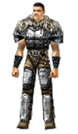
"Hey Kid, get me the goblet of Gomez, the leader of the ore barons. If you succeed, you may be of some use to us!"
This world is full of dangerous criminals. It's THEIR world, and all you are is a fresh chunk of meat. This means they won't just be hanging around all day waiting for you to come along and speak to them. On the contrary! Try persuading the angry chef – who, by the way, weighs one hundred and eighty pounds and simply can't stand you – that you're worthy of a meal ...
They work in mines, sleep, stand on guard, make fun of new arrivals, test their abilities in brawls and duels and go hunting, all the while prepared to fight for their lives and the defense of their property. Over 200 characters are ready and waiting to either talk to you or bash your face in, depending on your actions. Never forget that they all have friends who are more than willing to defend them or their territory. Watch your step and when you've thought twice before stealing something from one of these people, think again – you don't even want to know what they're capable of doing to you! Worst of all, they all have an excellent memory! So be very careful who you steal from ...
"Some people don't like others sticking their nose in where it doesn't belong." Shadow, Alberto's right-hand man

The Beasts

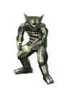
You sneak along the edge of the abyss, feeling every tendon in your arms tensing, sweat running down your muscles. On the other side of the dark canyon a huge troll has reared up, a bundle of muscles twice the size of any human being, but not even he can cross the gap between you. You take aim carefully, the deadly arrow shoots from the string and a moment later the gigantic creature's agonized cry pervades you. You prepare the next arrow, the monster's red eyes seem to pierce you. Just as you have your arrow perfectly placed, he flings something at you with a powerful sweep of his mighty arms. You duck. You are about to turn back to face the monster when you hear the fearce growl of a Gobbo right beside you! Even as you draw your sword to deal with this fiend, the troll takes aim again ...
Monsters can sense you approaching. Their behaviour varies whether they are hunting or fighting, weak creatures may join forces. One thing is for sure: they won't just sit around and wait for you to come along and kill them. They have a certain inbred pattern of behaviour. "(...)or just fiddle about with their feet." Michael Hoge, Art Director

The Controls

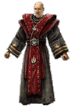
GOTHIC is controlled via an intuitive system that calculates all eventualities and is easy to learn. It is based on no more than 10 keys. The inventory is sorted automatically, according to the categories the various items belong to. "(...)We attach great importance to the symplicity of handling. Players won't have to click their way through dozens of menus and remember vast amounts of character values." Alex Brüggemann, Project Manager

The Art of Magic

"The trick is to unite your way of life with the way of magic!" Corristo, magician of the Circle of Fire
Magic plays an important role in GOTHIC, not just in that iron ore is the magical power source for the creation of important weapons. There are a number of chosen men in prison who control powers the rest of us mere mortals never even dreamt of. Their apprentices conscientiously choose the magicians of fire and water and the psionics as teachers of magic. Only those who prove themselves worthy will be given the chance to become a true master of magic. But a multitude of spells wait for everyone who treads the path of knowledge and the Arcanum; spells whose power shall affect the whole world!

The Way of War

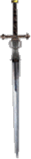
"Bet on me and your profits will be doubled!" Scar, first bodyguard of Gomez, before the battle in the arena
Steel blades hack away at one another, two bodies are intertwined, skip aside, try to find a gap in their opponent's defense. One slash follows another – slashes whose power would fast cost a slow or inattentive fighter his life. You hold your breath as you watch their movements. How different is the elegance of their actions from the way you wield your club! "Have no fear, my boy," the old man chuckles. "Someday you will learn to fight just like that. But don't expect it to be an easy matter."
The world of GOTHIC is full of peril. Learning to master your weapons can be helpful in dealing with the dangers you will certainly encounter. You will learn how to use weapons with one hand or two, how to use a longbow or a crossbow and how to improve your fighting skills. Prepare yourself for the fight of your life, or end up as many of your predecessors did – stone-dead.

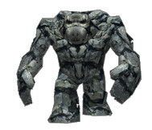
The Situation

Three groups have formed in the penal colony.
One of them is the OLD CAMP, built from the sweat of the miners and lead by the ore barons, who control most of the trade with the world outside.
The second group is known as the NEW CAMP. In time, the members of the new camp were liberated from the hierarchy of the old camp and set up their own small mine, all the while working obsessively on a plan for their escape.
The third group is the temple. The beliefs of those in the temple are as much of a mystery to everyone else as their power, but they have always kept well out of the conflict between the two other groups. Well, until now ...

The Setting

GOTHIC is set in a huge world full of breathtaking daytime and nighttime landscapes with three large camps, vast plains, deep woods, stupendous waterfalls, caves, windy mountains and much, much more – providing an unrivalled atmosphere supported by captivating music and authentic sound effects, varying according to the circumstances.
"Huge, surprising, dangerous and brilliant." Horst Dworczak, level god

System Requirements
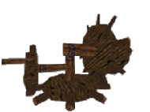
Pentium II-300
128 MB RAM
600 MB free hard disk space
3D accelerated card (DirectX)
Windows compatible sound device
8x CD-ROM drive
DirectX 7.0 or higher
Windows 95/98/2000

